LO2: Reconfiguring Digital Value Chains & Business Model Canvas
The four key shifts shown in the slide are:
- Linear → Ecosystem Value Chains
- Physical Resources → Digital Key Resources
- High CapEx → Cloud OpEx
- Traditional Revenue → Digital Revenue Streams

1. Linear → Ecosystem Value Chains
What does it mean?
A traditional linear value chain usually looks like:
Supplier → Business → Distributor → Customer
The business controls most of the process.
A digital ecosystem connects multiple businesses, customers, platforms and technology providers.
Business ↔ Customers ↔ Partners ↔ Platforms ↔ Suppliers ↔ Technology Providers
Instead of doing everything itself, the company uses a digital platform to coordinate different participants.
Example: Grab
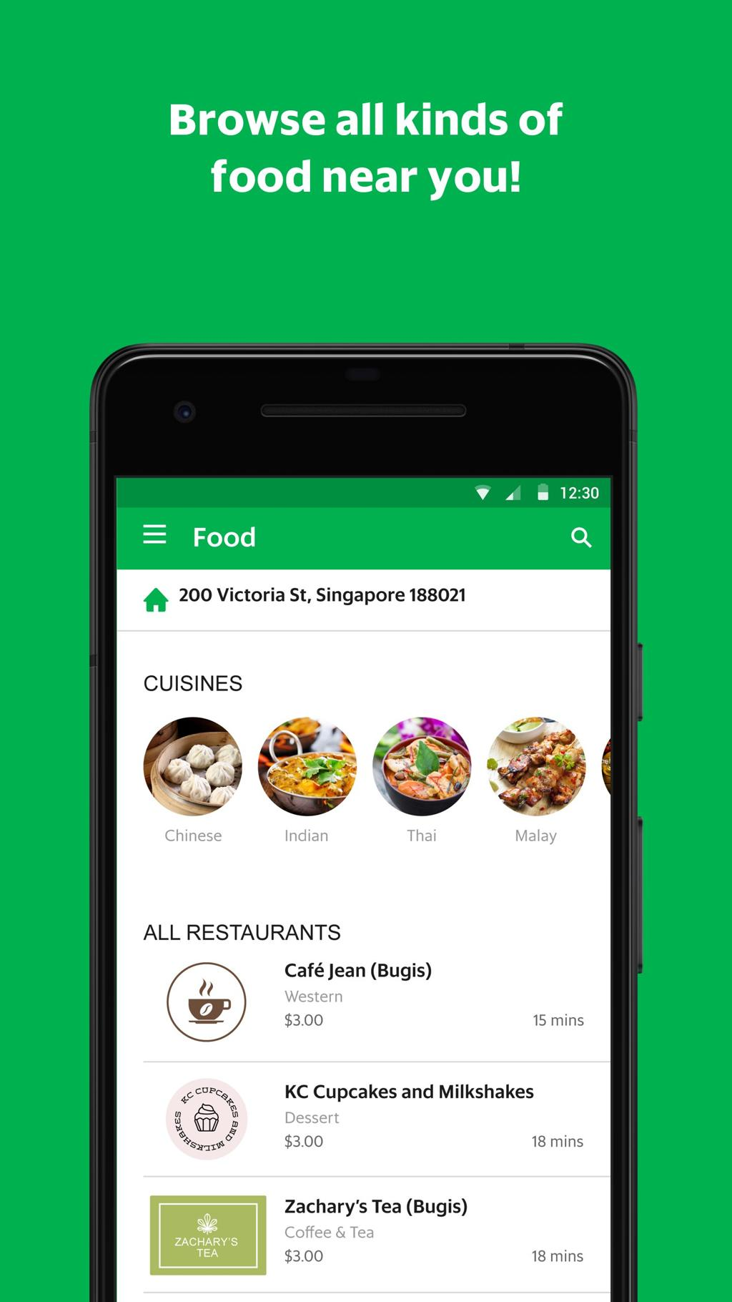
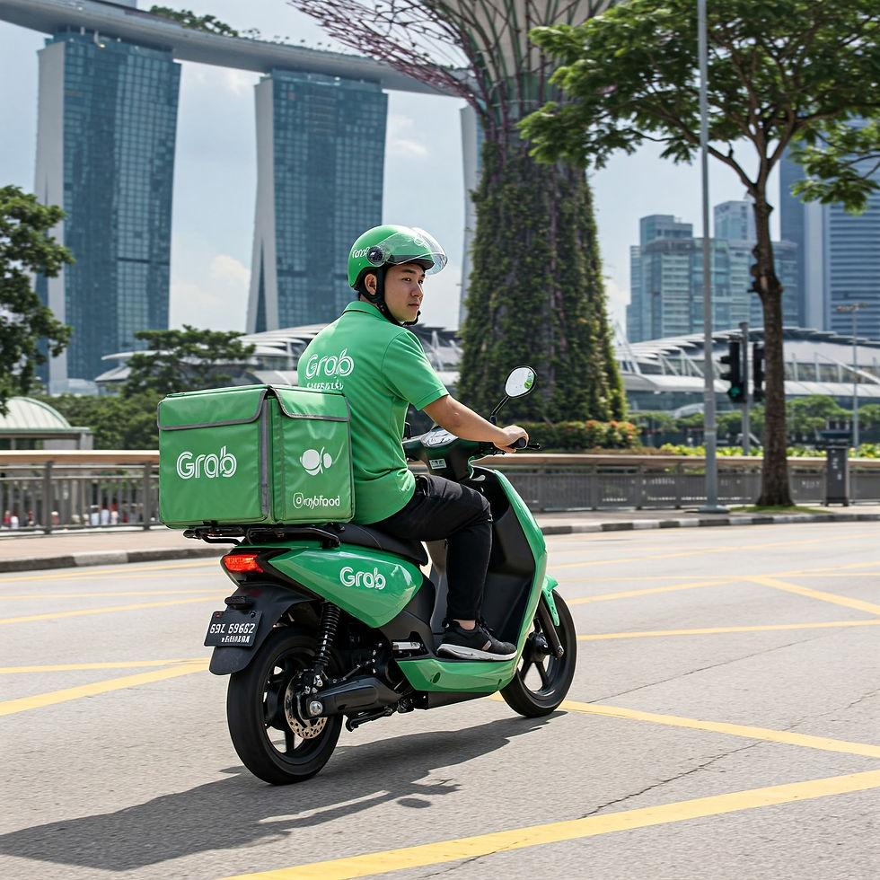
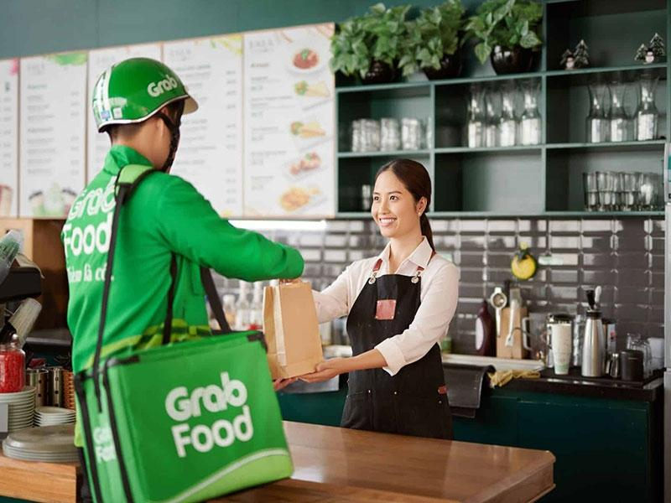

Traditional taxi business:
Taxi company → Taxi → Passenger
A digital ecosystem such as Grab is much more complex:
Customer
↕
Grab platform
↕ ↕ ↕
Driver | Restaurant | Delivery Partner
↕
Payment provider | Map provider | Technology providers
What is happening?
A customer uses the Grab app to:
- Book a ride
- Order food
- Make payment
- Track delivery
- Rate the service
Grab does not need to own every restaurant, car or delivery vehicle.
Instead, the digital platform connects different participants.
Business Model Canvas connection
BMC Component | Traditional Taxi | Digital Ecosystem
Key Partners | Taxi operators | Drivers, restaurants, payment providers, technology partners
Key Activities | Provide taxi service | Operate platform, matching, payments, data management
Key Resources | Cars, drivers | App, platform, data, algorithms
Channels | Taxi stand/phone | Mobile app
Customer Relationships | Human interaction | App + automated recommendations/support
Student takeaway
Digital ecosystems allow a business to create value by connecting multiple participants rather than owning every resource involved in delivering the product or service.
2. Key Resources: Physical Assets → Data, AI, Cloud & Algorithms
What does it mean?
Traditional businesses often depend heavily on physical assets.
For example:
Hotel → Buildings + Rooms + Furniture + Reception
Digital businesses can create significant value from intangible digital resources:
- Customer data
- Software
- Algorithms
- AI models
- Cloud infrastructure
- Digital platforms
- Intellectual property
Example: Netflix
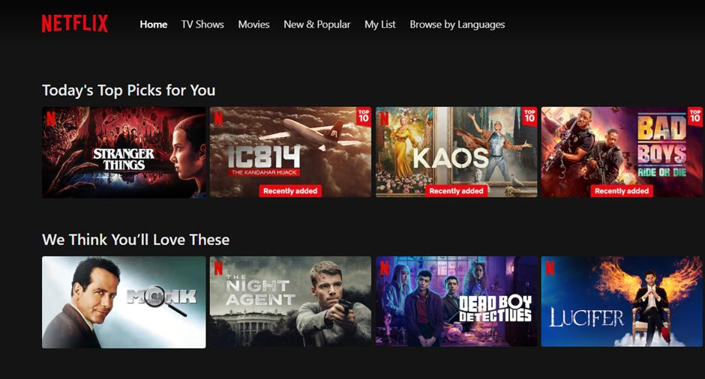



A traditional video rental business needs:
- Physical stores
- DVDs
- Shelves
- Retail employees
- Storage space
Netflix's key resources are much more digital:
Netflix's digital resources
1. Customer data
Netflix can analyse:
- What users watch
- How long they watch
- What they search for
- When they stop watching
- Which genres they prefer
2. Recommendation algorithms
The system uses viewing behaviour to recommend content.
For example:
"Because you watched X, you might also like Y."
3. Cloud and streaming infrastructure
Customers don't need to visit a physical store.
4. Digital platform
The Netflix application becomes the main channel through which customers access the service.
The important shift
Traditional video rental:
Physical stores + DVDs = major resources
Digital streaming:
Data + software + algorithms + content + cloud infrastructure = major resources
Business Model Canvas
The Key Resources box changes dramatically.
Instead of:
Stores + DVD inventory + physical equipment
It becomes:
Platform + customer data + recommendation algorithms + content library + cloud infrastructure
3. Cost Structure: High CapEx → Cloud OpEx
This is one of the more technical concepts on the slide.
What is CapEx?
CapEx = Capital Expenditure
Money spent on major physical assets that are expected to be used over a long period.
Examples:
- Servers
- Buildings
- Data centres
- Machinery
- Vehicles
Traditional IT example
Suppose a company wants to build its own data centre.
It may need to spend:
$2 million on servers + networking equipment + cooling + physical infrastructure.
This is a large upfront capital investment.
What is OpEx?
OpEx = Operating Expenditure
Ongoing expenses required to operate the business.
Examples:
- Cloud computing fees
- Software subscriptions
- Internet services
- Employee salaries
- Monthly platform fees
Instead of purchasing its own servers, a company can use cloud providers and pay according to usage.
Example: A Small Online Retailer
Imagine ABC Fashion wants to launch an online store.
Traditional approach
ABC Fashion purchases:
- Physical servers
- Networking equipment
- Storage
- Backup systems
It spends a large amount before getting many customers.
Cloud approach
ABC Fashion uses cloud computing.
It pays based on its usage.
For example:
Low customer traffic → lower computing requirements
High customer traffic → scale computing resources upward
So the cost structure changes from:
Large upfront investment
⬇️
More flexible ongoing operating costs

Real-world example: Shopify merchants
A small business doesn't need to build its own e-commerce infrastructure.
It can use an existing digital commerce platform and pay subscription/transaction-related fees.
This dramatically reduces the amount of infrastructure the business needs to purchase itself.
Business Model Canvas connection
The Cost Structure changes from:
Buildings + servers + IT infrastructure + maintenance
to:
Cloud services + software subscriptions + platform fees + digital marketing + transaction fees
Important clarification
The phrase "near-zero marginal cost" on the slide does not mean digital businesses have zero costs.
For example, streaming one additional video to a customer still consumes computing, bandwidth and other resources.
It means that the cost of serving one additional customer can be relatively small compared with traditional physical expansion, particularly after the digital infrastructure has been established.
4. Revenue Streams: Traditional → Subscription, Freemium, Marketplace & Data
Digital businesses have created many new ways to generate revenue.
The slide highlights four important examples.
A. Subscription — SaaS
SaaS = Software as a Service
Instead of selling software once, the company charges customers regularly.
Example: Microsoft 365
Traditional software model:
Buy software → Install → Use
Digital SaaS model:
Subscribe → Access online → Pay monthly/yearly
For example, a business may pay for Microsoft 365 based on the number of users and the selected plan.
Business Model Canvas
Revenue Stream:
Recurring subscription revenue
Why is this attractive?
The business can potentially create:
- Predictable recurring revenue
- Long-term customer relationships
- Continuous opportunities for upgrades
B. Freemium
Freemium = Free + Premium
The basic service is free, but customers pay for additional features.
Example: Spotify
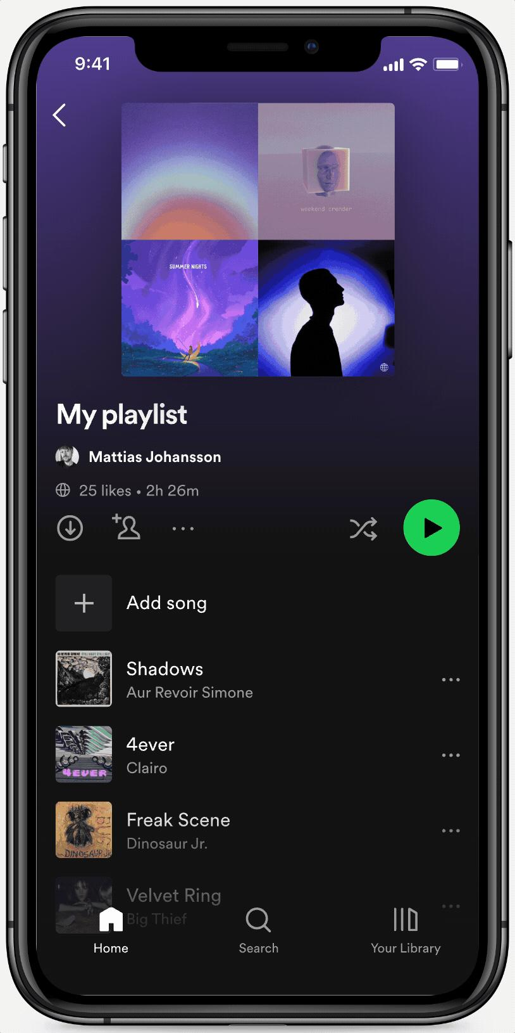
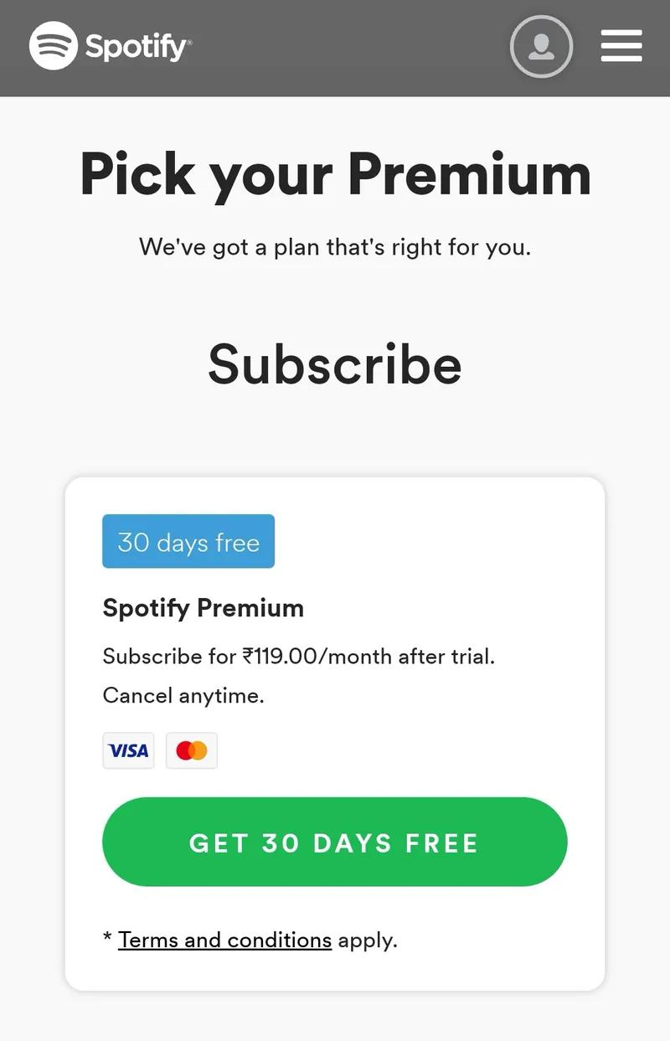
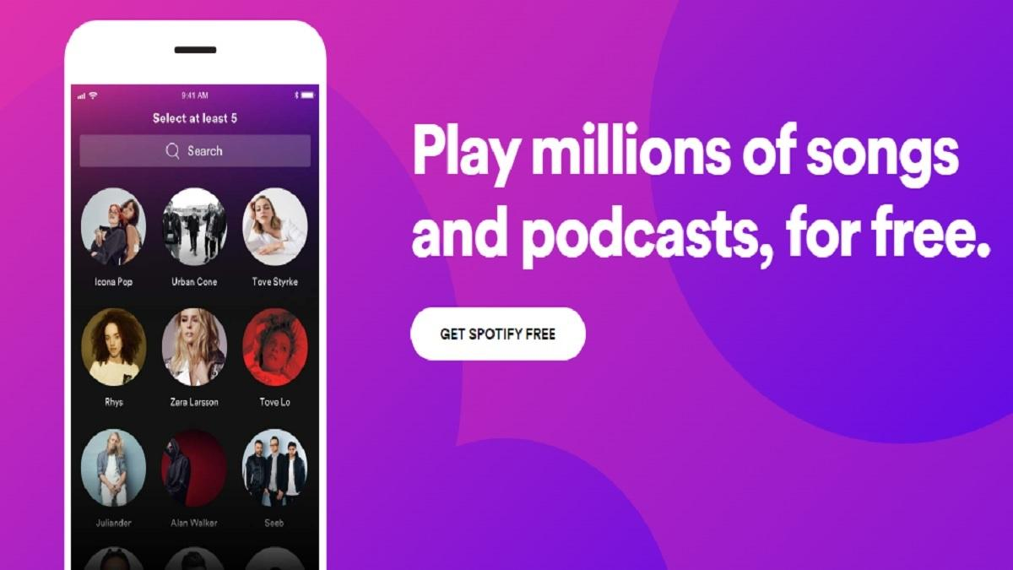
5
Spotify can attract users with a free service.
Free users
May receive:
- Advertising
- Restrictions on certain features
- Limited control over listening
Premium users
Pay for additional benefits such as:
- Ad-free listening
- Additional control
- Offline listening
So the business model is:
Free users → attract large audience → some users convert to Premium → subscription revenue

C. Marketplace Transaction Take-Rate
This is particularly important for businesses such as Grab, Airbnb and online marketplaces.
The platform doesn't necessarily own the products being sold.
Instead:
Customer → Platform → Seller/service provider
The platform takes a percentage or fee from the transaction.

Example: GrabFood
Imagine a customer orders:
$30 meal
The restaurant prepares the food.
The platform facilitates:
- Customer discovery
- Ordering
- Payment
- Delivery coordination
- Tracking
The platform may earn revenue through commissions and/or fees associated with the transaction.
Key idea
The platform can generate revenue without producing the food itself.
This is an excellent example of a digital ecosystem.

D. Data Monetisation
Data can become an important digital asset, although businesses must comply with applicable privacy and data-protection laws.
A business can create economic value from data through activities such as:
- Analytics
- Personalisation
- Advertising
- Business intelligence
- Insights for partners
Example: E-commerce platform
Suppose an online retailer knows:
- Which products customers search for
- Which products are frequently purchased
- Which products are abandoned in carts
- Which promotions work
- Which customer segments buy particular products
The business can use these insights to:
Improve recommendations → Increase conversion → Increase revenue
A platform may also provide aggregated or appropriately governed insights to business partners.

Putting All Four Shifts Together
Let's use Grab to connect the concepts.
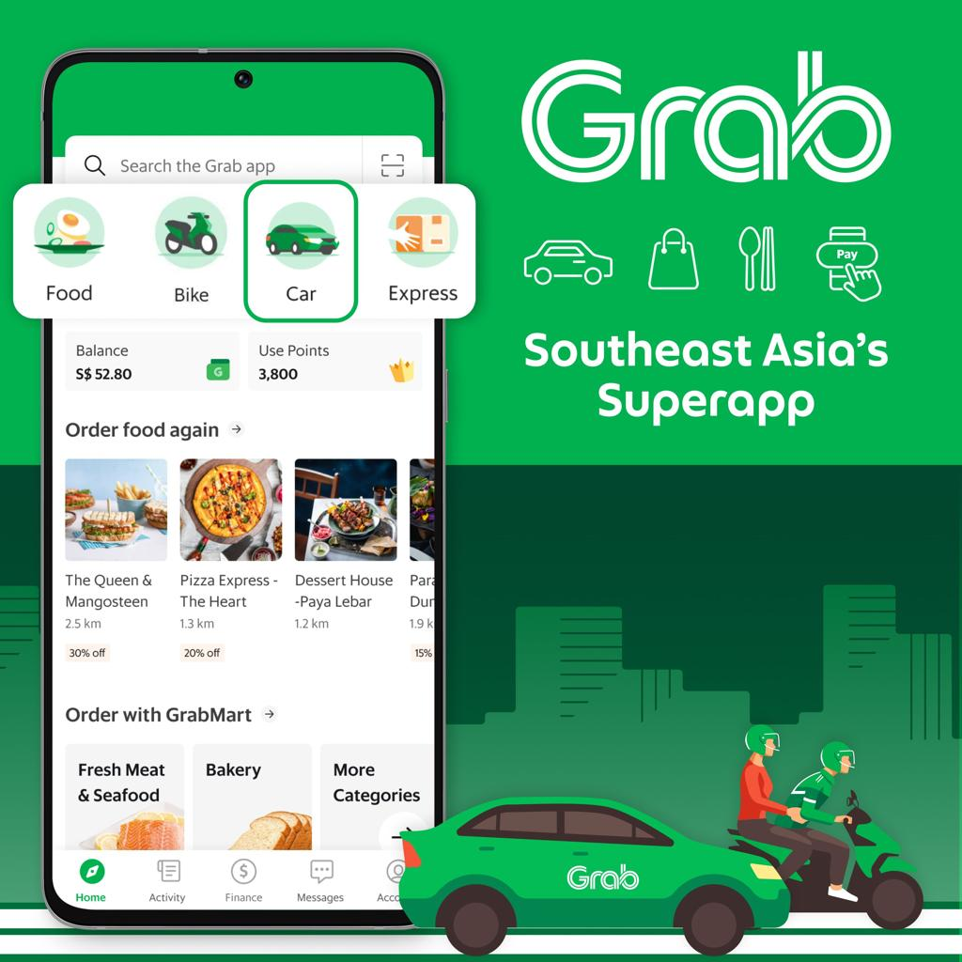
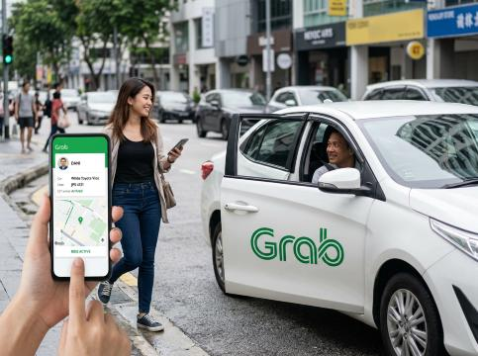
8
Traditional Business Model | Digital Business Model
Taxi company owns/controls vehicles | Platform connects drivers and customers
Linear value chain | Ecosystem
Physical assets are critical | App, data and algorithms are critical
Large physical infrastructure | Cloud-based infrastructure
Customer calls/bookings | Mobile app
Fixed service relationship | Data-driven personalised experience
Payment for individual service | Transaction fees, commissions, subscriptions and other digital revenue mechanisms
Limited customer information | Rich customer and transaction data
This demonstrates how one digital transformation can affect almost every part of the Business Model Canvas.

Another Excellent Example: Airbnb
Airbnb is particularly useful for teaching this topic because students can immediately see the difference between a traditional hotel and a digital platform.
Traditional hotel
Hotel owns building → Provides rooms → Customer pays hotel
Airbnb
Host → Airbnb platform → Guest
Airbnb doesn't need to own most of the properties listed on its platform.
1. Ecosystem Value Chain
Airbnb connects:
Hosts ↔ Airbnb ↔ Guests
and also interacts with:
- Payment providers
- Cleaning/service providers
- Technology providers
- Local businesses
2. Digital Key Resources
Airbnb's key resources include:
- Digital platform
- Customer/host data
- Search and recommendation algorithms
- Reviews and ratings
- Brand
- Payment infrastructure
3. Cloud OpEx
Rather than each property needing its own digital booking infrastructure, Airbnb operates a centralised digital platform supported by scalable technology infrastructure.
4. Revenue
Airbnb generates revenue primarily through fees associated with bookings rather than owning the properties being rented.

A Simple Classroom Explanation
You can explain the entire slide to students using this scenario:
Traditional Pizza Business
Imagine a pizza company.
Old model:
Buy shop → Buy ovens → Hire workers → Make pizza → Customer visits → Customer pays
Now digitise it.
Digital Pizza Business
Step 1 — Ecosystem
Restaurant + Delivery platform + Drivers + Payment provider + Customer
Step 2 — Digital resources
Instead of relying only on ovens and restaurants:
Customer data + ordering app + algorithms + digital payment + CRM
Step 3 — Cloud
Instead of building expensive IT infrastructure:
Use cloud-based POS, CRM and ordering systems.
Step 4 — Digital revenue
Instead of only:
Customer buys pizza → $20
The business can introduce:
Pizza sales + delivery fees + subscriptions + loyalty programme + marketplace commissions

How This Connects to the Business Model Canvas
This is probably the most important connection for LO2.
BMC Component | Digital Transformation
Key Partners | Ecosystem partners become more important
Key Activities | Platform management, data analytics, automation
Key Resources | Data, AI, software, algorithms, cloud
Value Proposition | Convenience, personalisation, speed, accessibility
Customer Relationships | Automated and data-driven relationships
Channels | Apps, websites, social media, digital platforms
Customer Segments | More precise data-driven segmentation
Cost Structure | Cloud OpEx, software subscriptions, digital marketing
Revenue Streams | Subscription, freemium, commissions, transaction fees, advertising
In one sentence:
Digital transformation reconfigures the Business Model Canvas by changing who participates in value creation, what resources are important, how the business operates and how it earns revenue.

Easy Student Framework
For an assessment or classroom activity, give students a traditional business and ask them to answer these four questions:
① Ecosystem
Who can we connect with digitally?
Suppliers + partners + customers + platforms
② Digital Resources
What digital assets could create value?
Data + AI + algorithms + software + cloud
③ Cost Structure
What physical infrastructure can technology reduce or replace?
Servers → Cloud
Physical paperwork → Digital systems
Physical stores → E-commerce
④ Revenue
How can digital technology create new revenue?
Subscription
Freemium
Commission
Transaction fee
Advertising
Data-driven services
That gives students a practical way to move from understanding the theory to actually "reconfiguring" a Business Model Canvas.

